**SPH3U 6.5 Heating and Cooling Systems**

1. **Conventional heating systems**

3 conventional heating systems:

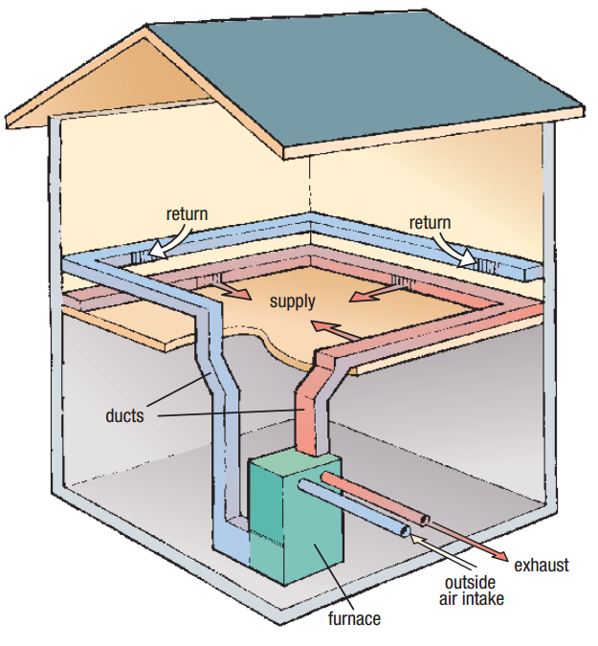

1. **Conventional cooling systems**

Condenser:

Evaporator:

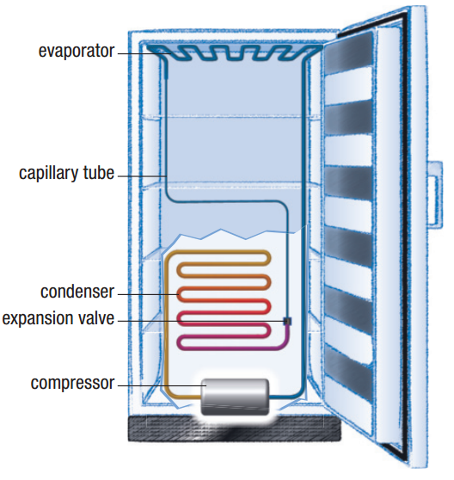

1. **Controlling heating and cooling**

Bimetallic strip:

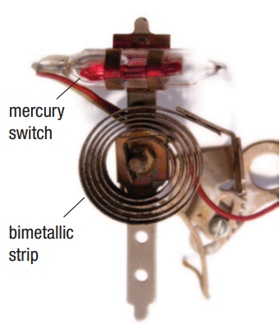

1. **Geothermal systems**

Temperature 3 m below ground:

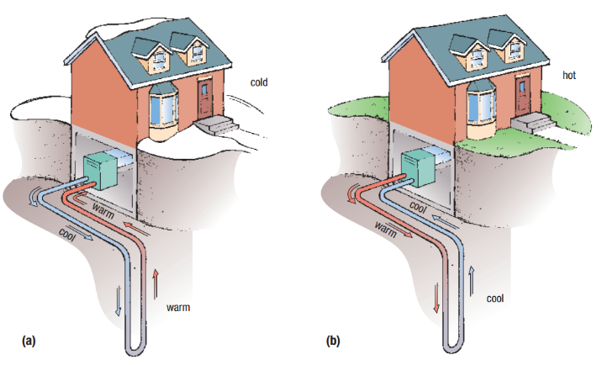

**Homework:** page 299: #1, 4